M AMRITA
Business Analyst | BFSI DOMAIN |Capital & Wealth Markets | Trade Lifecycle|
​ 9019087992 ​ amritamukhergee@gmail.com ​ https://www.linkedin.com/in/amrita-mukherjee-9b0285399/ ​ Bangalore

SUMMARY
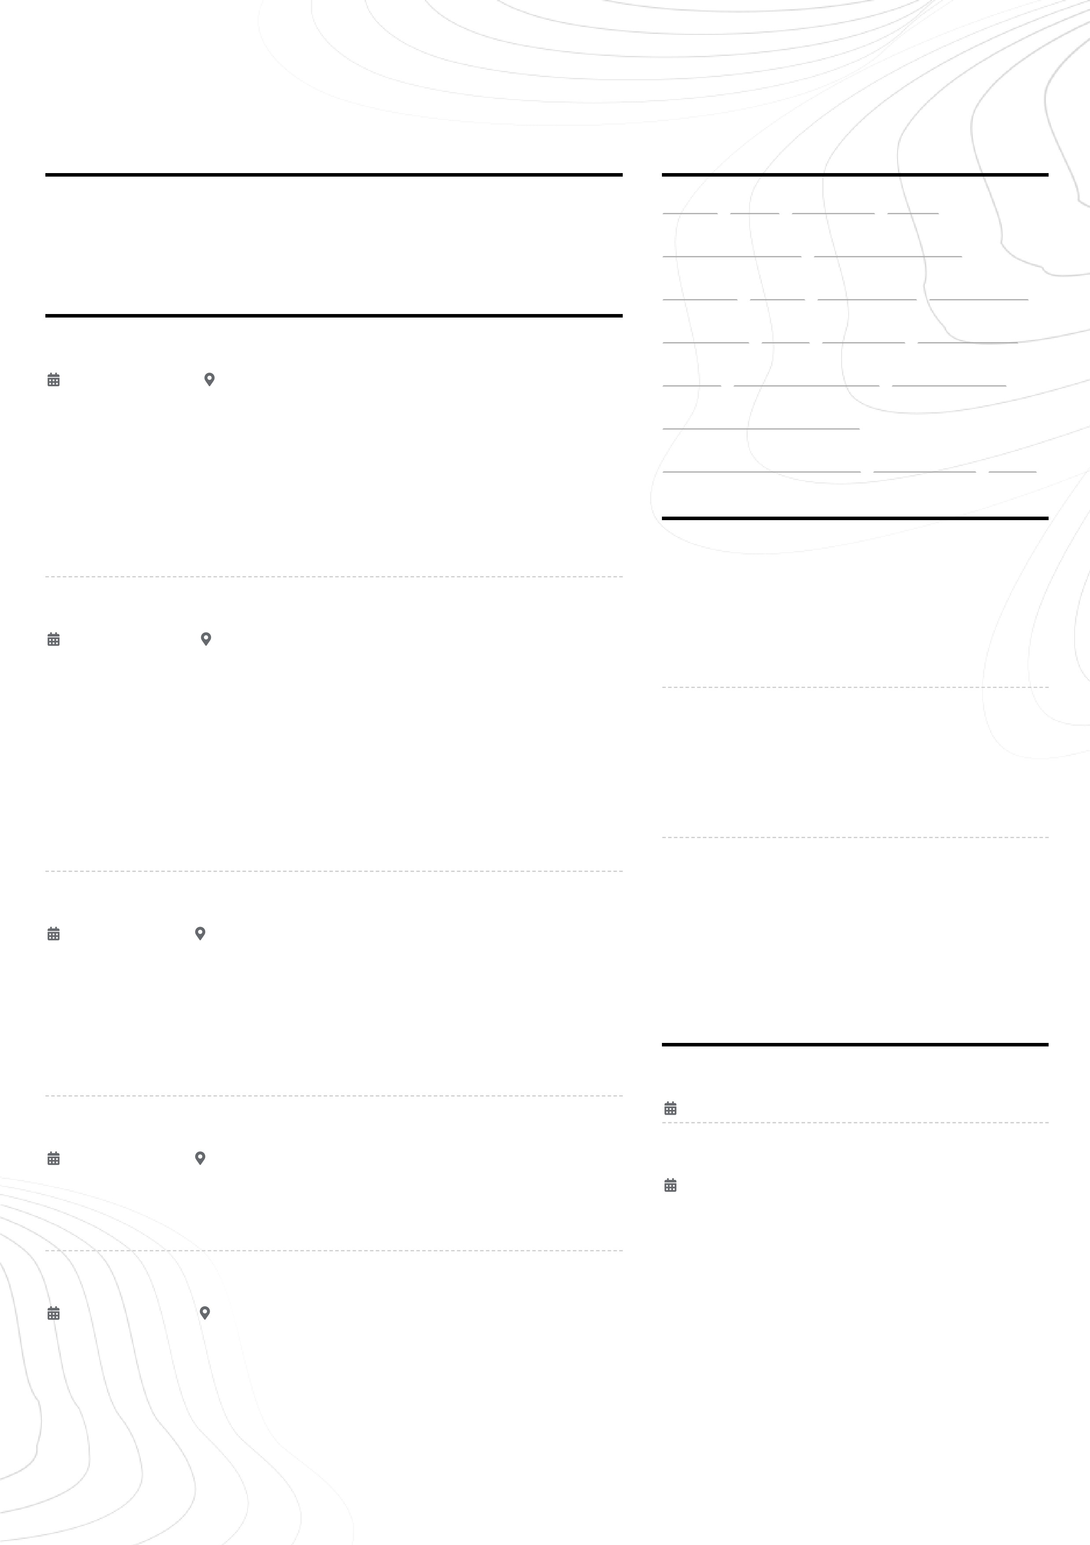
I am a forward-thinking Business Analyst with over 5 years of experience in banking, real estate, and wealth management. My expertise lies in stakeholder alignment, solution design, and agile project management, leading cross-functional teams in global settings. I have successfully driven digital transformations, delivering impactful solutions and value to clients in capital markets and consulting

EXPERIENCE

Senior Business Analyst

IndusInd Bank
02/2024 - 02/2025 Bangalore
A major private sector bank in India
- Writing UAT, User Stories, Working on Sprint Planning, interacting with internal and external stakeholders
- Engage client to gather software requirements/ business role and ensure alignment with development teams
- Draft and maintain business requirements and align them with functional and technical requirements
- Preparing and analyzing system use cases/ BRDs
- Familiar with creating Use case Diagram, Activity Diagram and Balsamiq Wireframes
- Complete Knowledge of SDLC & Software development Process

Business Analyst

Standard Chartered Bank
01/2022 - 01/2024 Bengaluru
A leading international bank offering a range of financial services
- Managed end-to-end requirements gathering and solution delivery for financial institutions in capital markets and wealth management, including FX and interest rate products.
- Collaborating with Clients and stakeholders while keeping them informed of progress and issues
- Reviewing required performance reports on daily, weekly, and monthly schedules to external and internal teams
- Managing Scope to avoid scope creep and ensuring agreed scope is delivered
- Working with developers to clarify required enhancements
- Conducted JAD with industry experts to document business process functionality
- Functional testing of the system to ensure alignment with client requirements

Business Analyst

Housing.com
11/2019 - 12/2021 Gurgaon
A real estate listing platform in India
- Created BRDs, solution documentation, requirement traceability matrices RTM , and test scenarios.
- Performed functional testing to validate system functionality and product effectiveness.
- Provided training to new joiners to improve process understanding and operational efficiency.
- Identified and resolved impediments during daily Agile sprint meetings.

Deputy Sales Manager

Quikr
11/2017 - 01/2019 Kolkata
An online classifieds platform in India
• Led client acquisition and seller onboarding through cross-functional coordination, delivering daily MIS reports, consistently meeting targets, and driving client retention.

Sales Executive

Mahindra Holidays & Resorts India Limited
07/2015 - 03/2017 Kolkata
A leading player in the vacation ownership and leisure resort sector
• Identified new business opportunities and maintained strong client relationships to deliver high-quality customer service.
www.enhancv.com

SKILLS
Agile UAT Waterfall JIRA
Microsoft Project Microsoft Power BI
Tableau Visio Lucid Chart Confluence
KYC/AML SQL Balsamiq Wireframes
SDLC Functional Testing GAP Analysis
Stakeholder Management
USER Acceptance Testing User stories BRD

PROJECTS

Capital Markets Trading Platform Revamp
Capital Markets Trading Platform Revamp
- Collaborated with global stakeholders on FX and IR product lifecycle upgrades
- Defined business and functional requirements, supported UAT
- Mapped end-to-end trade flows across front, middle, and back-office teams

Wealth Management Digital Onboarding
Wealth Management Digital Onboarding
- Led requirement gathering and process redesign for client onboarding
- Worked with technology teams to develop a scalable, compliant digital solution
- Achieved a 25% reduction in account opening time

Real Estate Marketplace Integration
Real Estate Marketplace Integration
- Analyzed user journeys and data flow for a regional property platform
- Streamlined vendor onboarding workflows and reduced operational friction
- Implemented automated documentation and API integrations

EDUCATION

MBA in Marketing and Finance
WBUT
01/2013 - 05/2015

B. Sc. in Comp. Sc

Calcutta University
01/2010 - 05/2013
Powered b_{y} ​

